Cycle to Work - Halfords
What is Cycle to Work - Halfords?
Cycle to Work is a salary sacrifice benefit that gives employees access to bikes and accessories through a nationwide network. As a salary sacrifice benefit, employees agree to give up part of their gross salary in exchange for this benefit, which reduces the amount of tax and National Insurance employees pay. The scheme is easy to manage and fully supported by our team.

✅ Direct Partnership with Halfords – We work closely with Halfords to deliver a reliable and well-established Cycle to Work scheme..
✅ Wide Retail Network – Employees can shop at over 1,250 retailers, including Halfords, tredz.co.uk, and 800+ independent bike shops.
✅ Flexible Access – Employees can join anytime and use any device to manage their benefit.
✅ 24/7 Support – Our helpdesk is available year-round to assist employees whenever they need help.

Who is this guide for?
This guide is aimed at public sector employers with admin access.
Who is the Partner?
Our partner for Cycle to Work is Halfords. Halfords works with a large network of cycling retailers, including tredz.co.uk and over 800 independent bike shops, to provide employees with access to bikes and accessories. This partnership ensures employees can choose from a wide range of options, supporting healthier commuting and active lifestyles.
Employee Journey – Applying for Cycle to Work
Step 1 – Log In
Access your account via SmartHub or the Connect+ mobile app.
Step 2 – Find Cycle to Work
Navigate through the mega menu or select the MyBenefits tile.
Step 3 – Start Application
Click Apply Now to begin the process.
Step 4 – Go to Halfords Portal
You’ll be redirected to the Halfords portal.
Step 5 – Continue
Click Continue to proceed.
Step 6 – Enter Details
Provide your personal information as requested.
Step 7 – Verify Email
Halfords will send a One-Time Password (OTP) to your email for verification.
Step 8 – Confirm and Access
Enter the OTP to validate your email and access the Halfords site.
Step 9 – Place Your Order
Select your bike and accessories to calculate how much to request and place an order for the exact valuation.
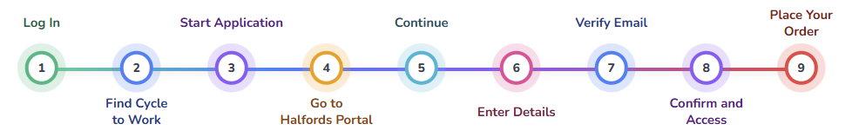

Cycle to Work – Approval Process
Who approves applications?
Halfords sends application details to the employer by email for approval. The employer clicks the link in the email to open the Halfords approval portal, where they approve or reject applications. Employers must provide the correct distribution list for these email notifications.
Employer approval journey
Step 1: Sign in to Halfords for Business
Go to https://www.halfordsforbusiness.com/SignIn and log in with your credentials.
Step 2: Access the Applications Screen
Navigate to the Applications section to view pending requests.
Step 3: Review Pending Approvals
Check the list of applications awaiting your action.
  - Is this an employee of my organisation?
  - Are they working their notice?
  - Have they provided all the information correctly which I need to set up deductions? e.g. payroll number
  - Will the value they have take them below minimum wage?
Step 4: Open a Record
Select an individual request to view its details.
Step 5: Check the Request Details
Verify the information provided by the employee before making a decision.
Step 6: Update the Action Status
Choose either Approved or Rejected based on your review.
Step 7: Submit the Status
Click Submit to save your decision.
Step 8: Repeat for Remaining Records
Move to the next pending application and follow the same steps.
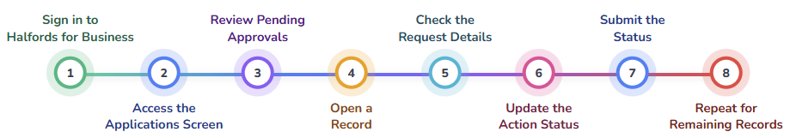
Is the process Manual or Automatic
This is a manual approval process.

When are approvals done?
- Approval Timing and Impact
Approvals are sent as soon as the employee completes their application. Employers can choose how often they log in to the Halfords portal to review and approve requests, but delaying approval also delays the release of the Letter of Collection (LoC), which is the voucher employees need to purchase their bike and accessories.
- LoC Delivery After Approval
Once the application is approved, the Letter of Collection (LoC) is automatically and instantly emailed to the employee directly by Halfords.
- Outcome of Rejection
If an employer rejects a Cycle to Work application in the Halfords approval portal, the application is cancelled and no Letter of Collection (LoC) is issued. The employee is notified that their request has been declined, and the process ends without any salary sacrifice deductions being applied. If the rejection was made in error, the employee must submit a new application for approval.

Approval Notifications
- Pending Approval Email Alerts from Halfords
Employers receive an email from Halfords for every pending approval request.
- Outcome Notification to Employee
Once the employer approves or rejects the application, the employee receives an email with the decision.
- Letter of Collection Issued
If approved, the employee receives a Letter of Collection (LoC) by email, allowing them to purchase the bike and accessories for the approved value.
If the employee wants to cancel
- How to Cancel
In all cases, employees (or next of kin in the event of death) must contact Halfords directly.
- Cooling‑Off Period
You can cancel within the 14‑day cooling‑off period with no issue.
- After 14 Days
Once the cooling‑off period has passed, cancellation may not be possible. This depends on the provider’s (Halfords exceptional circumstance) rules.
- What Happens Next
When Halfords confirms your cancellation with Reward Gateway Edenred, SmartPay will update your application status to “Cancelled.”
Cycle to Work – Invoicing Process
Who Invoices Who
Reward Gateway Edenred generates the invoice and sends it directly to the Employer. Employers will only ever receive invoices from Reward Gateway Edenred.
Frequency
Invoices are raised monthly, typically dispatched on or around the 10th of the month. Invoices will only show employees who have passed the 14 day cancelation period, this minimises the risk of employee payroll deductions occurring prematurely.
How Invoices Are Generated
Invoices are created by our finance system and sent to the employer by email with the invoice attached.
Client Payment
The employer is responsible for settling the invoice within the agreed payment terms. Importantly, employees can still use their Letter of Collection (LoC) before the invoice has been paid.
Invoice Enquiries
Employers should direct all invoice‑related queries to the Reward Gateway Edenred Finance team only.
- Accounts Receivable-RG <accounts.receivable@rewardgateway.com>
Reporting
Application Backing data
Employers can obtain backing data for any invoice directly from the SmartPay module within Reward Manager.
Step 1 Click on the Invoices tile
Step 2 Select the products to show: Halfords - Cycle to work
Step 3 Apply filter
Step 4 Click Export (which downloads the CSV file for you)
Deduction Report
A deduction report provides the employer with the information needed to make Halfords deductions to an employee’s payroll on a case-by-case basis. Details include employee name, benefits used, total deduction amount, the current deduction, and how much is left to pay off.
Employers can also filter the deduction report to show only new, continuous or closing applications, or they can choose to show them all together. The report can be downloaded into a CSV format where it can be formatted to meet each client's needs.
There are two reports available for you to choose from based on your requirements:
- Detailed Report: This report offers deduction information for each order made by an employee.
- Summary Report: This report presents the overall deductions for each employee.
Downloading a report
Check out this article for guidance on how to download a Deduction Report.
https://success.rewardgateway.com/hc/en-us/articles/18118097380765-SmartPay-Deduction-Reports-for-UK-only
End of hire period rules
When your Hire Agreement ends, Halfords will contact you about transferring ownership of your bike and accessories. This is required to keep the scheme compliant. You’ll have three options:
- Extend the Hire Agreement
Continue the agreement at no cost. At the end of the extension, you can take ownership for free. (Most popular option)
- Return the Goods
Return your bike and accessories to a local Halfords store with nothing more to pay.
- Take Ownership Immediately
Pay a one-off charge based on the fair value of the goods. Bikes under £500 have an 18% residual value after 12 months, reducing to zero after 4 years. Bikes over £500 have a 25% residual value after 12 months, also reducing to zero after 4 years.
Partner Links
- General FAQs (includes interactive chat)
- Halfords Customer Service 0330 135 9779

