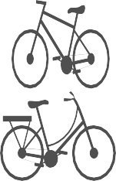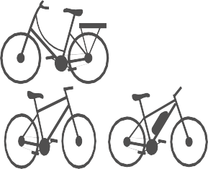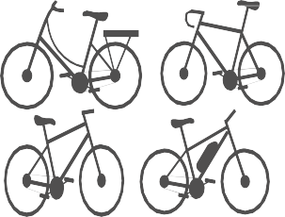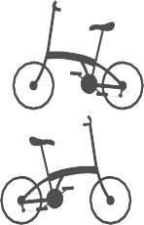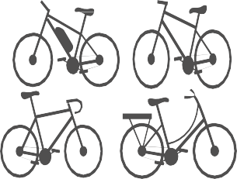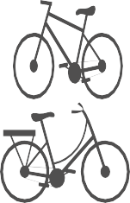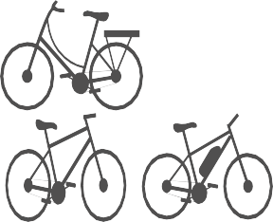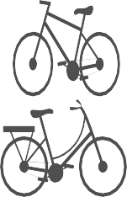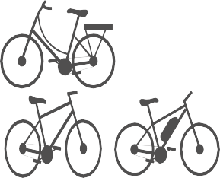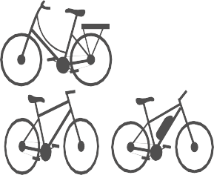

Roadshow Booking form
Please take the time to complete the information within this form. If we are missing details, we cannot progress the request and may result in us not having availability for
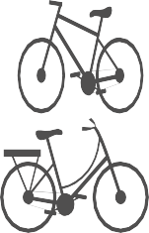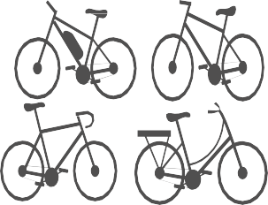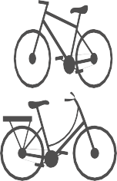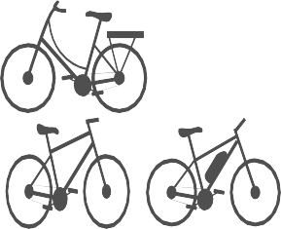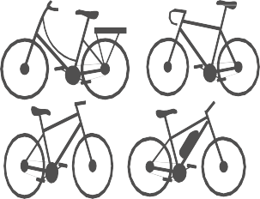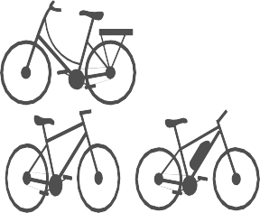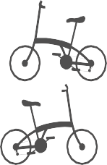the desired dates/times.

Name Of Company:
Time:
Date of the Roadshow:
(We run the roadshows to cover the main lunchtime period of 12:00 – 14:00, but we can be flexible with this if needed)

Roadshow Location:
(Please provide full postal address)
Expected Number of Employees On site:
Hosts contact details
(These will be used to confirm site details with our roadshow executives)
Parking arrangements for a 2 meter high van
(We must be able to park to be able to attend)
Security/Onsite covid rules
Location on site of roadshow
(We will require a table to display our marketing and to be set up in an area of high footfall, usually this will be a canteen or common room)
Benefits day or
Stand-alone C2W roadshow

